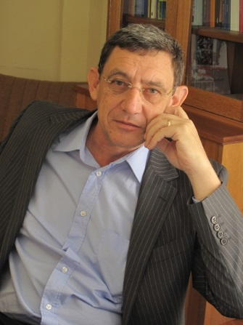
Prof Pieter du Toit is an Associate Professor in the Faculty of Education at the University of Pretoria. He has been a guest lecturer at Iowa State University, the University of Oklahoma and the University of Antwerp, where he also held a postdoctoral fellowship. His research activities include action research, learning styles (specifically whole brain learning), professional development and education innovation across faculties.
He has served as Vice-president of the South African Association for Research and Development in Higher Education (SAARDHE); as a member of the executive committee of the Higher Education Learning and Teaching Association of Southern Africa (HELTASA); and the executive committee of the Action Learning Action Research and Process Management Association Australia.
A registered Herrmann Brain Dominance Instrument (HBDI) practitioner with Ned Herrmann International which informs his research on whole brain learning, Prof. du Toit has published widely on teaching and learning in higher education and also served as editor of established peer-reviewed journals. His work has been recognised with an award for excellence in education innovation from the Department of Education Innovation at the University of Pretoria.

